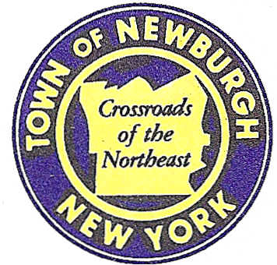

TOWN OF NEWBURGH
_______Crossroads of the Northeast __________________________
OLD TOWN HALL
308 GARDNERTOWN ROAD NEWBURGH, NEW YORK 12550

PLANNING BOARD
JOHN P. EWASUTYN, CHAIRMAN
TELEPHONE 845-564-7804
FAX 845-564-7802
E-MAIL: planningboard@townofnewburgh.org

PLANNING BOARD AGENDA

FEBRUARY 5, 2015

*PLEASE NOTE: The Planning Board Meeting will start at 7:00 P.M. and all Applicants/Representatives
are to be present at that time. The Meeting will be held in the Meeting Room of Town Hall,
located at 1496 Route 300, Newburgh NY.*

- Laxmi Estates (2006-23)  5277 Route 9W  Section 40, Block 2, Lot 20  Zone: B  Rep: Bloom & Bloom, PC  530 Blooming Grove Turnpike  New Windsor, NY 12553 | SITE PLAN
- Hudson Valley Chrysler Dodge Jeep Ram (2015-01)  200 Auto Park Place  Section 97, Block 2, Lot 11.2  Zone: IB  Rep: John Meyer Consulting  120 Bedford Road  Armonk, NY 10504 | INITIAL APPEARANCE  SITE PLAN
- Webb Properties (2014-10)  Route 17K & Auto Park Place  Sec. 97; Blk. 2; Lots 35 & 43  Zone: IB  Rep: A. Diachishin & Associates  115 Yankee Folly Road  New Paltz, NY 12561 | SITE PLAN / ARB
- Birks Realty/Webb Properties (2014-30)  Unity Place, Auto Park Place & Route 17K  Sec. 97, Blk. 2, Lots 11.2, 13.2, 32, 35 & 43  Zone: IB  Rep: A. Diachishin & Associates  115 Yankee Folly Road  New Paltz, NY 12561 | SUBDIVISION & LOT LINE CHANGES
- Ironworkers Local 417 - Training Facility (2015-02)  - 583 Route 32  - Section 4, Block 3, Lot 5.2  - Zone: R-R  - Rep: Andrew Fetherston, P.E.  Maser Consulting  1607 Route 300, Suite 101  Newburgh, NY 12550 | INITIAL APPEARANCE  SITE PLAN / BUILDING ADDITION
- Hampton Inn & Suites and Restaurant (2014-16)  Route 17K & Crossroads Court  Section 95, Block 1, Lot 45.12  Zone: IB  Rep: Maser Consulting  1607 Route 300, Suite 101  Newburgh, NY 12550 | SITE PLAN / ARB

*WORK SESSION: Project Readiness Discussion scheduled for 5:30 p.m. in the Meeting Room of Town Hall on Thursday, February 5, 2015*

PLANNING BOARD BUSINESS
WORK SESSION

February 5, 2015
5:30 P.M.

Discussion:

- Reappointment of Landscape Architect, Karen Arent, RLA.
- Trinity Square (2006-53):
The Applicant is requesting a six month conditional final approval extension from
21 February 2015 to 21 August 2015.

